PROJECT TOPIC

LUDO GAME USING PYTHON

**ABSTRACT:**

Ludo Game simulation is a computer program that imitates the manual method of playing ludo board game. We faced the problem in trying to analyze risk ratio and need to adapt continuously to the change of inner and outer conditions through the stimulation. We achieved by writing a computer program that allows players to roll a dice randomly, take decisions and move the tokens based on the outcome of the dice. Ludo is a strategy board game for two to four players, in which the players race their four tokens from start to finish according to rolls of a single die. Unless you get a ‘6’ when rolling the dice, your planes can’t take off. Press the ROLL button to roll the dice. If it is a 6, then you can take another turn. So press ROLL again. Click the plane which you want to move the first ROLL. The plane will move itself accordingly to the number of the dice .If the plane lands on stop, it cannot be killed. To win the game, your planes have to traverse around the board and come into the home lane.

**INTRODUCTION:**

Ludo is a strategy board game for two to four players, in which the players race their four tokens from start to finish according to rolls of a single die. Ludo is derived from the Indian game Pachisi, but simpler. The game and its variants are popular in many countries under various names. Special area of the ludo board are typically colored bright yellow, green, red and blue. Each player is assigned a color and has four tokens of matching color.

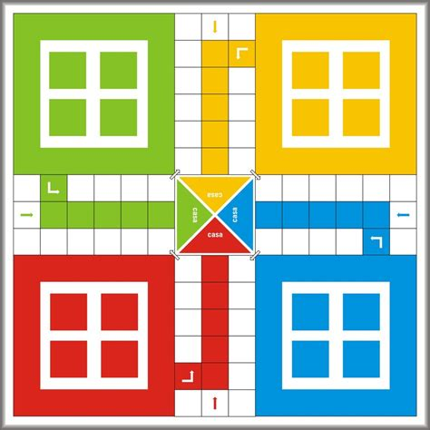

**DESCRIPTION**:

Left part of the window has ludo board and tokens and right part of the window has controls. To play the game follow below steps:

* Roll dice by clicking on Roll button.
* Select which toke you want to move .
* To move a token click on Move button.
* Repeat same for next player.

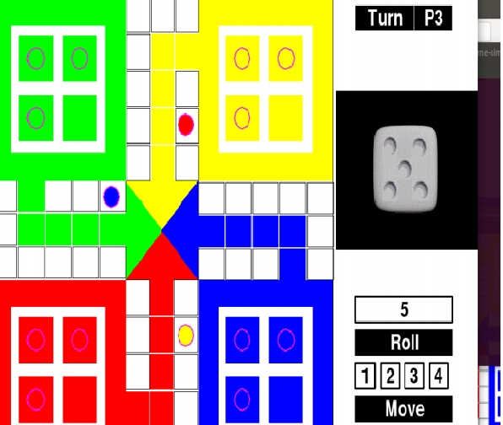

**SOFTWARE REQUIREMENTS**:

Ludo game simulation implemented in:

* Python
* Pygame Library

**METHODS USED**:

* rendertext( ) : Makes a reactive version of the given function that also uses cat to turn its result into asingle-element character vector.